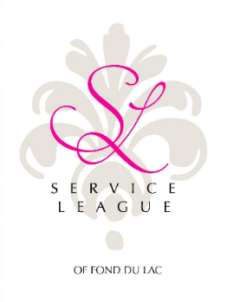
Service League GRANT Request Form

Organization Information Date Submitted: ____________

Name of Organization: ______________________________________________________________
Address: ___________________________________________________________________________

Contact Person Information

Name: _________________________________
Title: _______________________________
Phone: ________________________________
E-mail: ________________________________

Is your organization’s 501c3 status current? Yes No
What is the mission of your organization? ___________________________________________

Amount requested:_______________ *When are funds needed by?_____________
*We typically have a TWO month turn- around time to approve requests.
*Grant processing unavailable May 1st-Sept 1st
Brief description of the project or program needing funding:

*Please provide a budget of the program expenses.
(This application must be signed by the president or another officer of the organization’s governing body:)

Signature:______________________________ Print name:________________________
Return this application to: Service League of Fond du Lac, Inc.
P.O. Box 185,
Fond du Lac, WI 54936-0185
Or email to : Serviceleaguefonddulac@gmail.com

